# **Good Health And Wellbeing**

# **HealthyLife AU: Personalized Health Insights**

——Turning Australian health data into simple, personalized lifestyle advice

# 



TP07 | Health Hub

Date: 25/08/2025

# 

# Introduction

HealthyLife is a privacy-friendly health platform that transforms official health data from Australia into clear and personalized lifestyle insights. Our goal is to help young Australians quickly understand the risks of their lifestyle and obtain simple and feasible advice. By making official data truly serve individuals, it helps them make small but meaningful changes and that lead to healthier lives.

# Project Overview

## Problem Statement

Australians are increasingly affected by preventable lifestyle-related conditions such as obesity, type 2 diabetes, cardiovascular diseases, cancer, and respiratory illnesses, largely due to poor diet, physical inactivity, smoking, and alcohol consumption; national health data shows that dietary risks and excess weight are now the leading contributors to preventable disease, yet individuals lack personalized insights that compare their habits with population-level trends. Despite open-access data from sources like ABS, AIHW, and the Department of Health, this information is not used to deliver tailored health-risk awareness, guidance, or dietary support. As a result, people may unknowingly maintain habits that elevate their risk of chronic disease.

**How might we help Australians understand the health risks associated with their lifestyle—and support them through personalized dietary highlights, nutrient insights, and lifestyle change simulations—to improve their wellbeing?**

## Target Audience

Healthylife AU is designed for urban young people aged 18 to 35, including busy students and working people. They are health-conscious, but lack the time and tools to manage their lifestyles effectively. They often eat out and lack exercise, making it difficult for them to find clear health guidance. By focusing on this group, our goal is to transform the health data that is difficult for the general public to understand into quick and personalized insights and integrate them into their daily lives.

## News articles

# [7,000 steps a day linked to reduced risk of chronic disease and death, study finds – ABC News](https://www.abc.net.au/news/health/2025-07-25/step-count-7000-health-benefit/105571904)

# [Australians living longer but with more chronic disease, COVID 'excess deaths' jump: national health report – ABC News](https://www.abc.net.au/news/health/2022-07-07/health-australians-living-longer-but-with-more-chronic-disease/101213626)

# [Obesity rates are rising in Australia, but it's where you live that matters– ABC News](https://www.abc.net.au/news/health/2019-10-11/obesity-rates-depend-on-where-you-live/10196154)

# Health conditions and risks - ABS

# [National preventive health monitoring dashboard - Australia Institute Health and Welfare](https://www.aihw.gov.au/reports/risk-factors/nat-preventive-health-monitoring-dashboard/data)

# Rates of Obesity and Disease Risk in Australia – The Art of Healing

# Rise in proportion of Australians with diabetes - ABS

# Heart, stroke and vascular disease: Australian facts – Australia Institute Health and Welfare

# [The Effectiveness of Gamification in Changing Health-related Behaviors: A Systematic Review and Meta-analysis – The Open Public Health Journal](https://openpublichealthjournal.com/VOLUME/17/ELOCATOR/e18749445234806/FULLTEXT/)

* [Effect of digital health applications with or without gamification on physical activity and cardiometabolic risk factors: a systematic review and meta-analysis of randomized controlled trials](https://www.thelancet.com/journals/eclinm/article/PIIS2589-5370%2824%2900377-8/fulltext)
* [The disease burden of overweight, obesity and poor diet - Obesity Evidence Hub](https://www.obesityevidencehub.org.au/collections/impacts/disease-burden-overweight-obesity-poor-diet)

# [Missing the target: Study predicts sharp decline in Australians’ diets by 2030 - CSIRO](https://www.csiro.au/en/news/All/News/2025/March/Study-predicts-sharp-decline-in-Australian-diets-by-2030)

* [Food-sensitive planning and urban design (FSPUD) – Heart Foundation](https://www.vichealth.vic.gov.au/sites/default/files/FoodSensitivePlanning_UrbanDesign_Summary.pdf)
* [Diet and Nutrition – ABC News](https://www.abc.net.au/news/topic/diet-and-nutrition)
* [What we’re doing about food and nutrition – Australian Governement](https://www.health.gov.au/topics/food-and-nutrition/what-were-doing)
* [Australians are choosing foods that contribute to leading causes of disease. Why? – SBS News](https://www.sbs.com.au/news/article/australians-choosing-foods-contibute-to-disease-why/1j5d3mbsx)

## Personas

## 

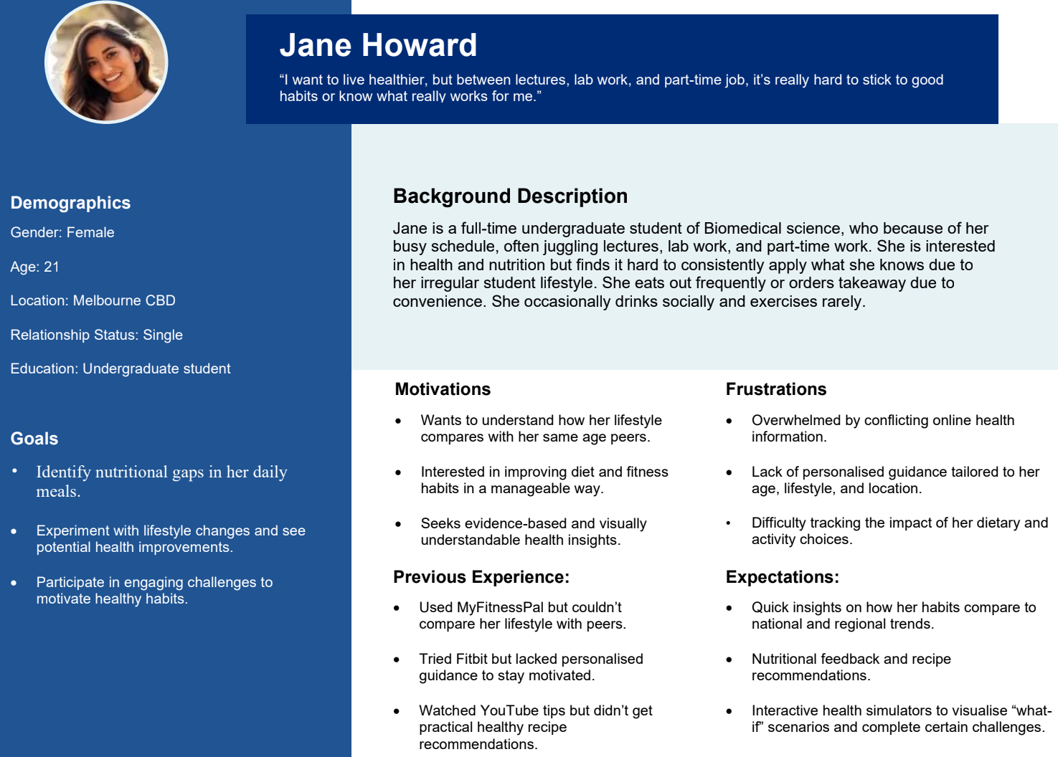

## Current Iteration

**EPIC 1.0 Lifestyle Insight & Risk Context**

**Must Have**

As a **Young Australian resident**, I want to input my lifestyle habits and instantly see how they compare with population averages so I can understand my risk levels.

This epic helps young Australians quickly understand the comparison of their living habits with the national average, allowing them to clearly understand their personal health risks.

**Benefits:**

* Provides a personalised baseline profile that makes the health insights and recommendations more relevant to the individual.
* Encourages self-reflection on daily habits, helping users become more aware of their lifestyle choices.
* Creates the foundation for tailored comparisons and feedback, ensuring future insights are accurate.
* Highlights how individual habits compare with national averages, making risks easier to understand.
* Motivates positive lifestyle changes by showing areas of concern relative to peers.
* Supports preventive health awareness and early action, especially for young Australians.

US 1.1 As an Australian resident, I want to complete a short lifestyle quiz about my diet, exercise, smoking, and alcohol habits so that the system can generate a personalised lifestyle profile for me.

US 1.2 As a Young Australian resident, I want to instantly compare my lifestyle results against national population benchmarks so that I can clearly understand whether my current habits place me at higher or lower risk compared to others.

**EPIC 2 .0 Interactive Health Simulator (What-If Tool)**

**Must Have**

As a **Young Australian Resident**, I want to adjust my habits virtually and see projected health outcomes so I can understand the benefits of positive change.

This epic enables users to virtually try out lifestyle changes and quickly see how these changes improve their health. It inspires people by showing them that even small adjustments can make a big difference over time.

**Benefits:**

* Allows users to experiment safely with lifestyle changes before committing to them in real life.
* Provides motivation by showing the potential health benefits of even small, positive adjustments.
* Helps users make informed decisions by clearly linking habit changes to projected outcomes.
* Provides clear visibility into how current and adjusted habits may impact long-term health.
* Encourages sustainable behaviour change by showing the positive outcomes of healthier choices over time.
* Builds awareness and accountability, helping users stay motivated to maintain healthier routines.

US 2.1 As a Young Australian resident, I want to virtually change one or more habits (e.g., increase exercise, reduce alcohol, quit smoking) so that I can explore different lifestyle choices without making immediate real-life changes.

US 2.2 As a Young Australian resident, I want to instantly view projected long-term health outcomes based on my adjusted habits so that I can clearly see the benefits of adopting healthier behaviours

**EPIC 3.0 Nutrition & Recipe Assistance**

**Should Have**

As a **Young Australian Resident**, I want to get feedback on my meals and suggestions for healthier recipes so I can improve my diet quality.

This epic helps users understand the nutritional value of their diet and discover the problems in it. It also offers simple recipe suggestions, making it easier for users to develop healthier eating habits in their daily lives.

Benefits:

* Gives personalised insights into meal quality, helping users quickly understand the health value of their food choices.
* Promotes better dietary awareness, making it easier to spot unhealthy patterns and areas for improvement.
* Encourages healthier eating habits through real-time feedback aligned with national nutrition guidelines.
* Provides tailored meal suggestions that match personal preferences, making healthy eating easier to adopt.
* Encourages sustainable dietary improvements by offering practical and realistic alternatives.
* Saves time and reduces decision fatigue by giving ready-to-use recipe options aligned with nutrition goals.

US 3.1 As a Young Australian resident, I want to log or upload details of my meals so that I can receive instant feedback on their nutritional quality and how they align with healthy eating guidelines

US 3.2 As a Young Australian resident, I want to receive personalised recipe recommendations based on my logged meals and dietary preferences so that I can improve my diet with healthier and practical alternatives.

## Datasets

| **Name** | **Link** | **Epic** | **Description** |
| --- | --- | --- | --- |
| Alcohol Consumption | [ABS - Alcohol Consumption](https://www.abs.gov.au/statistics/health/health-conditions-and-risks/alcohol-consumption/latest-release) | Epic 1 | Australian alcohol usage rates by age, sex, and geography |
| Smoking and Vaping | [ABS - Smoking and Vaping](https://www.abs.gov.au/statistics/health/health-conditions-and-risks/smoking-and-vaping/2022) | Epic 1 | Population smoking/vaping prevalence and trends |
| Overweight and Obesity | [AIHW - Overweight and Obesity](https://www.aihw.gov.au/reports/overweight-obesity/overweight-and-obesity/data) | Epic 1 | Obesity/overweight prevalence by age, sex, region |
| National Health Measures Surve | [ABS - NHMS](https://www.abs.gov.au/statistics/health/health-conditions-and-risks/national-health-measures-survey/2022-24) | Epic 1  Epic 2 | Biomarker data (cholesterol, blood pressure, blood glucose etc.) |
| Australian Burden of Disease Study | [AIHW - Burden of Disease 2024](https://www.aihw.gov.au/reports/burden-of-disease/australian-burden-of-disease-study-2024/data) | Epic 1  Epic 2 | Years of life lost (YLL), disease burden (DALY) for various diseases |
| Dietary Behaviour | [ABS - Dietary Behaviour](https://www.abs.gov.au/statistics/health/health-conditions-and-risks/dietary-behaviour/2022) | Epic 1  Epic 3 | Daily intake of fruits, vegetables, and discretionary foods |
| National Health Survey | [ABS - NHS 2022](https://www.abs.gov.au/statistics/health/health-conditions-and-risks/national-health-survey/2022#data-downloads) | Epic 1  Epic 2  Epic 3 | Includes chronic disease, lifestyle risk factors, mental health |
| Open Food Facts | [Open Food Facts](https://world.openfoodfacts.org/data) | Epic 3 | Global open food database with barcode info, nutrition labels |
| FSANZ Food Composition | [FSANZ Database](https://www.foodstandards.gov.au/science-data/food-composition-databases) | Epic 3 | Australian food nutrient content (per 100g) for |

# 

# Section B

Leankit: <https://monashie.leankit.com/board/2334440292>

# Section C

**Link to Design folder :** <https://drive.google.com/drive/folders/1LZibwu8wu0DONhxQSJPdTrav603BKKfp?usp=drive_link>

**Link to Security Plan :** <https://docs.google.com/document/d/1_7w5zusM3iFxUe77q6UymtLaq79v32Tx/edit?usp=drive_link&ouid=114886795725912857877&rtpof=true&sd=true>

**Link to Data Management Plan :**

<https://docs.google.com/document/d/1oQtVAoCAjpQoDpyshkudtVpTiqSaRygc/edit?usp=sharing&ouid=114886795725912857877&rtpof=true&sd=true>

Empathy map

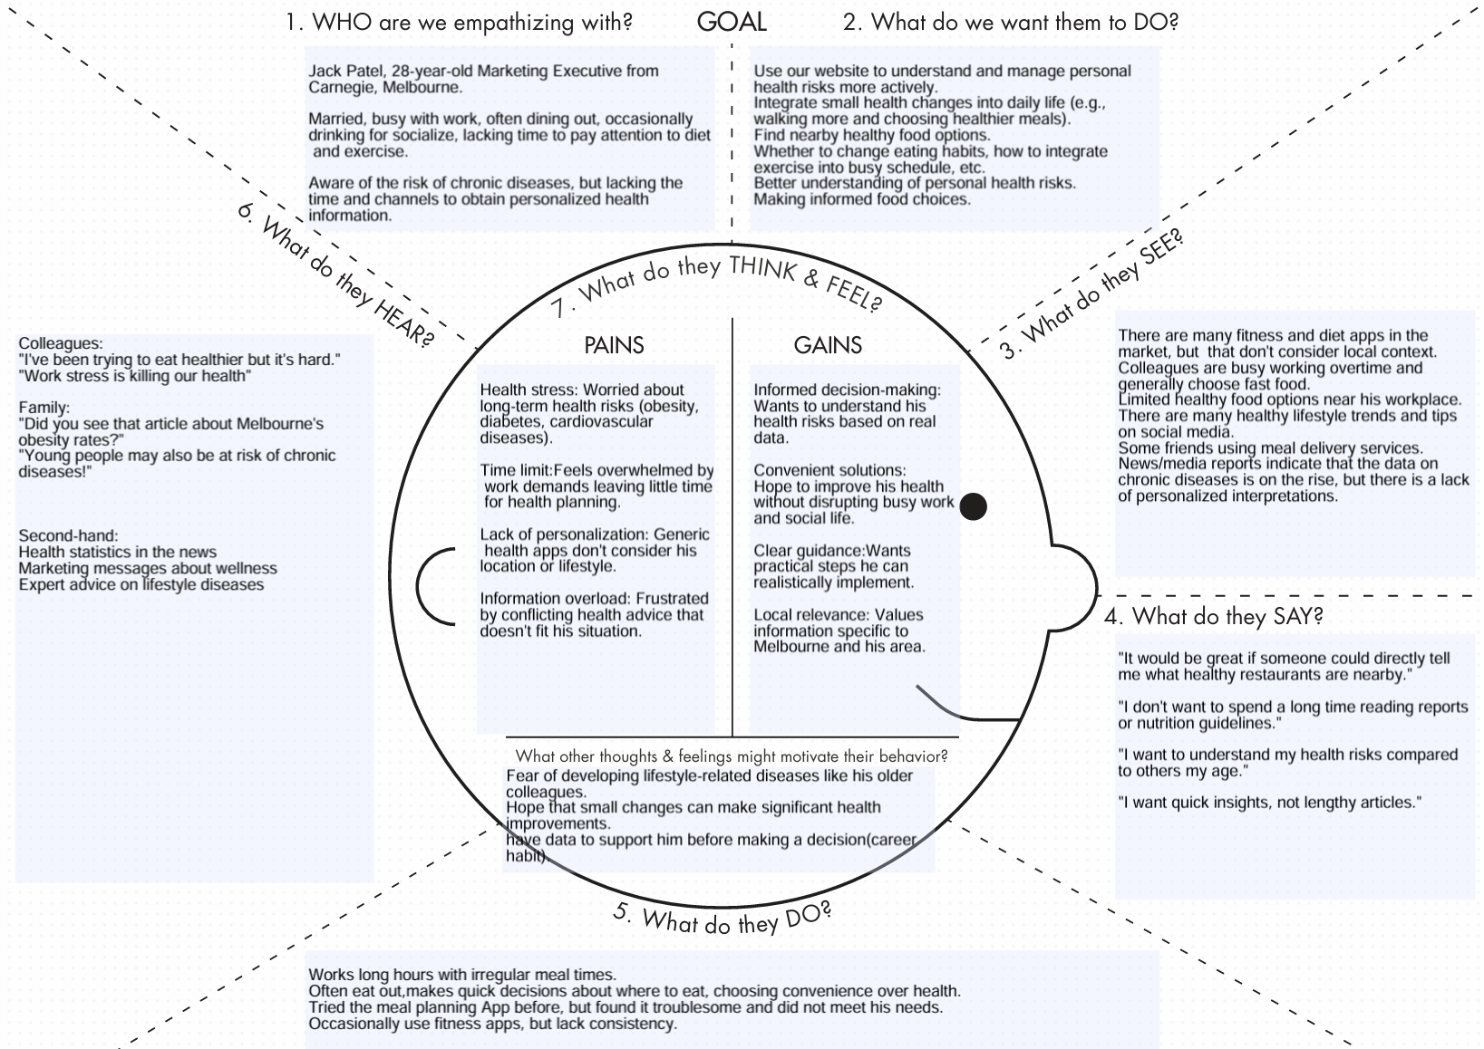

Lotus Blossom

